**DAILY ONLINE ACTIVITIES SUMMARY**

|  |  |  |  |  |  |  |  |  |
| --- | --- | --- | --- | --- | --- | --- | --- | --- |
| **Date:** | **07/06/2020** | | | | | **Name:** | **VANDANA** | |
| **Sem & Sec** | **IV sem & B section** | | | | | **USN:** | **4AL18CS095** | |
| **Online Test Summary** | | | | | | | | |
| **Subject** | | **-** | | | | | | |
| **Max. Marks** | | **30** | | **Score** | | | **-** | |
| **Certification Course Summary** | | | | | | | | |
| **Course** | **Introduction to Cyber Security** | | | | | | | |
| **Certificate Provider** | | | **Greatlearning academy** | | **Duration** | | | **5.5hours** |
| **Coding Challenges** | | | | | | | | |
| **Problem Statement1:** Write a C++ Program to swap two numbers using friend as a bridge concept. | | | | | | | | |
| **Status: Executed** | | | | | | | | |
| **Uploaded the report in Github** | | | | | **YES** | | | |
| **If yes Repository name** | | | | | **Online-coding** | | | |
| **Uploaded the report in slack** | | | | | **YES** | | | |

Online Certification Course Summary: Today I have learnt what is Cyber Security and different types of attacks involved in Cybercrime with this I have completed the course and attempted the quiz after that received the certificate of completion.

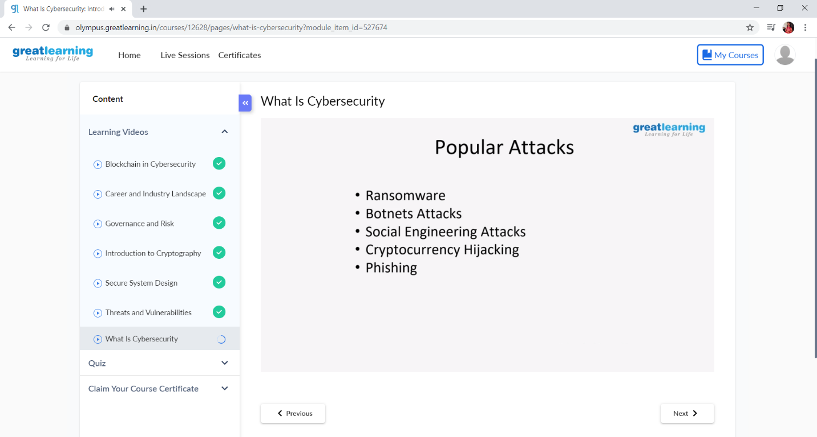

This is the snap shot of today’s session.

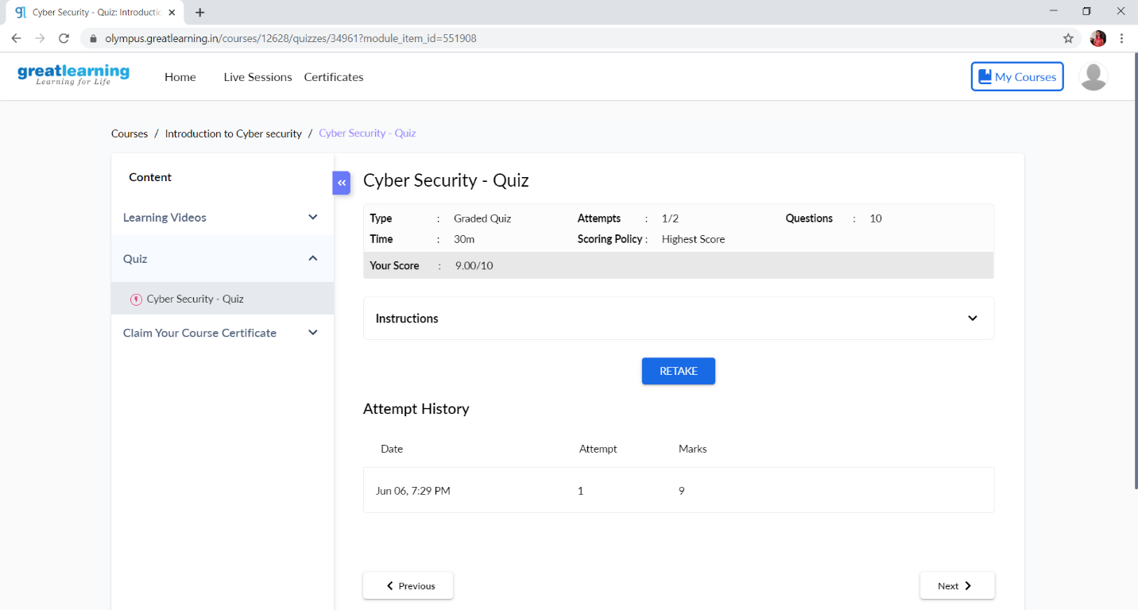

This is the snap shot of quiz attempted and the grade obtained.

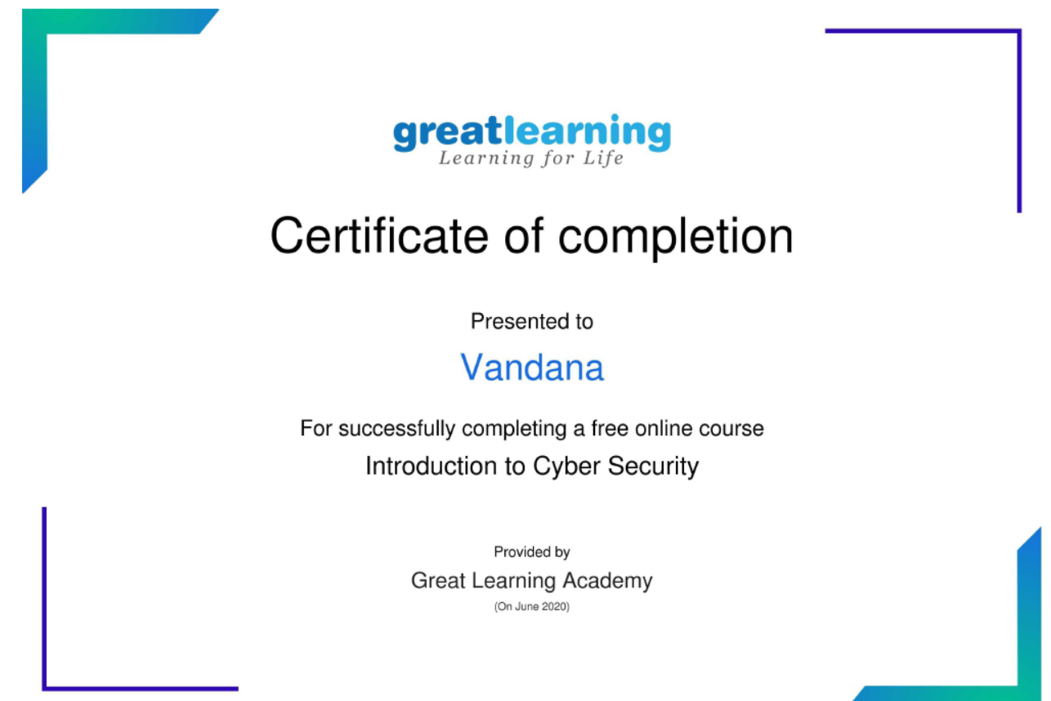

This is the snap shot of the certificate of completion.

Online Coding Summary: **Today I had received one program from prof. Shilpa CSE Dept. The program is mentioned above in the coding challenges(pg.01). I have also uploaded it to my Github repository.**

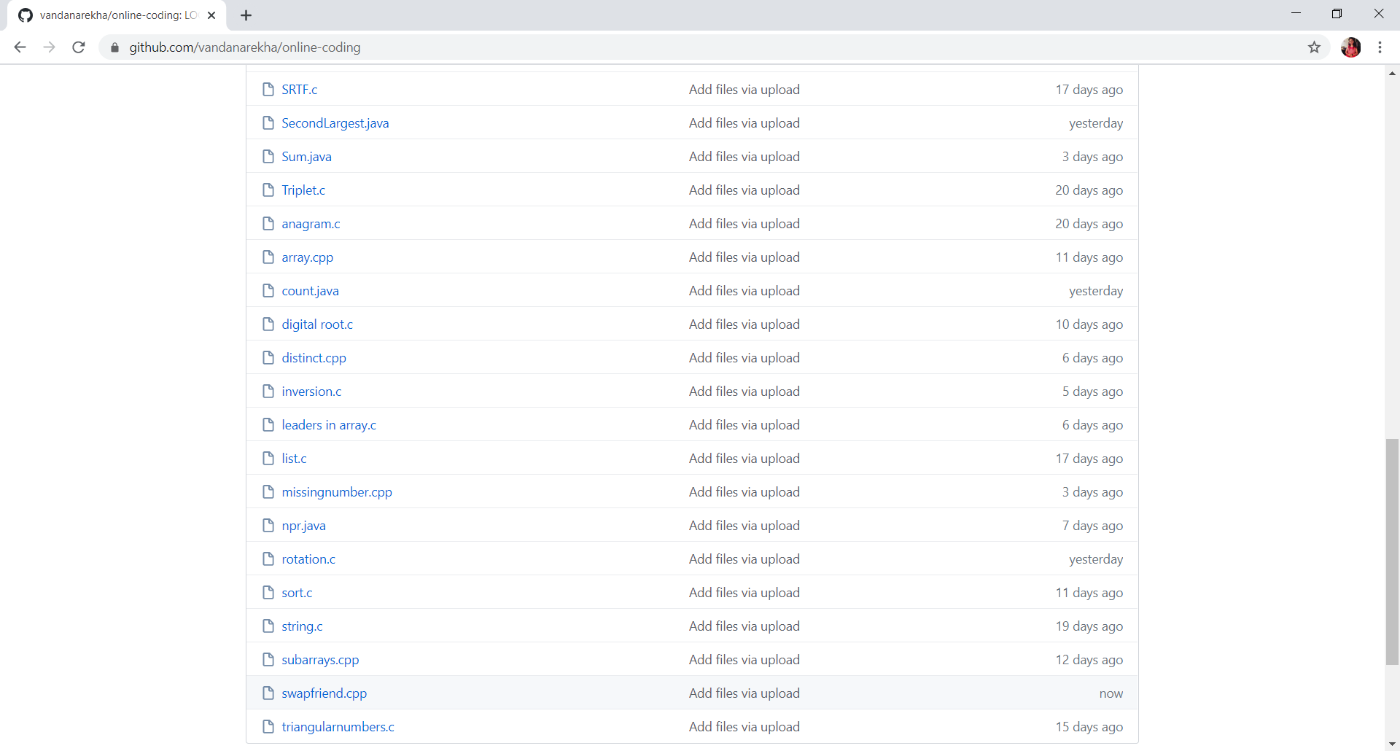

**This is the snap shot of my Github repository** were I have uploaded the code. File name is swapfriend.cpp